Cleaning and descaling materials
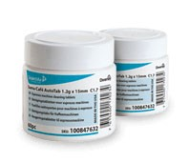 |  | 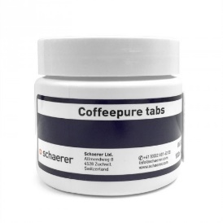 |  | 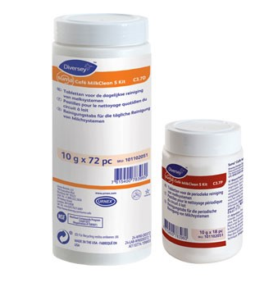 |  | 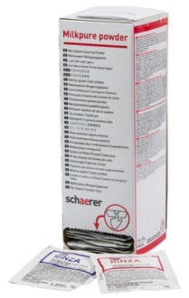
1 |  | 2 |  | 3 |  | 4
TP SUMA CAFÉ AUTOTAB 60PC C1.7 X2 |  | CLEANING TABLETS  100 PCS |  | TP SUMA CAFÉ MLK CL TABL KIT C3.7X1 |  | MILKPURE POWDER  1 BOX
5-9-2022 MSDS |  | 26-2-2020 U/  10-7-2023 S MSDS |  | 30-10-2018 MSDS |  | 18-3-2020 Alkaline  23-8-2018 Acid MSDS
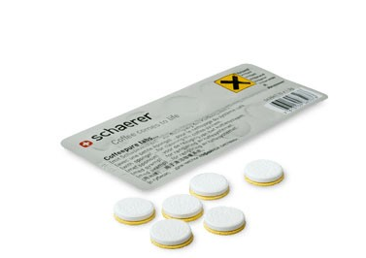 |  | 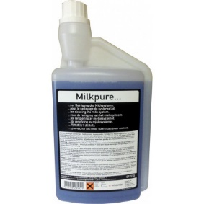 |  | 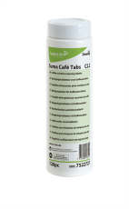 |  | 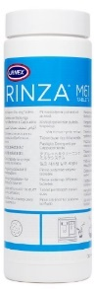
5 |  | 6 |  | 7 |  | 8
CL.TABLET 1X10-PACK BLIST.1.3G  1-3-2022 MSDS |  | MILKPURE 1000 ML  (Schaerer)  11-11-2019 MSDS |  | TP SUMA CAFÉ TAB  120PC C2.2 X2  17-6-2019 MSDS |  | TP RINZA CLEANING TABLETS 120PC X1  12-07-2018 MSDS
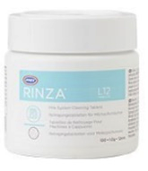 |  | 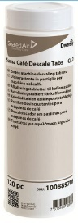 |  | 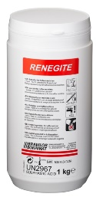 |  | 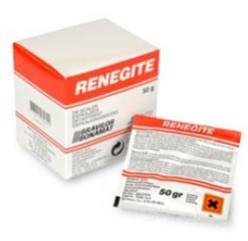
9 |  | 10 |  | 11 |  | 12
FDSOT RINZA CLEANING TABLETS 100PC X1 |  | SUMA DESCALE TABS C5.2 2X120PCS |  | RENEGITE 1 KARTON 10 x 1 KG |  | RENEGITE DECALC 15X50G X4
30-1-2018 MSDS |  | 27-2-2023 MSDS |  | 27.01.2021 MSDS |  | 27.01.2021 MSDS
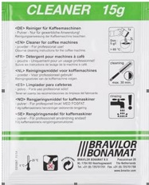 |  | 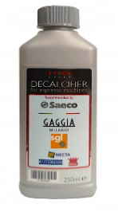 |  | 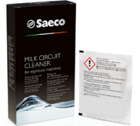 |  | 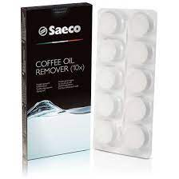
13 |  | 14 |  | 15 |  | 16
CLEANER (4X15 SACHETS OF 15 GR) |  | Acc NW Descaler 1U ROW 250ml |  | Milk cleaning powder - 6 pb |  | Coffee oil remover tablets
10-12-2014 MSDS |  | 4-4-2022 MSDS |  | 14-2-2022 MSDS |  | 26-5-2023 MSDS
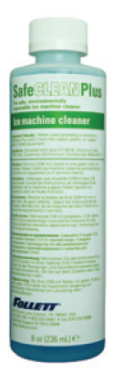 |  | 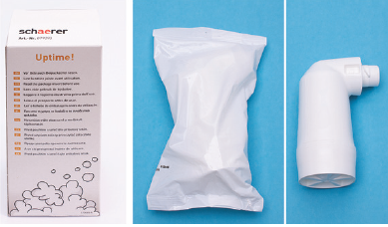 |  | 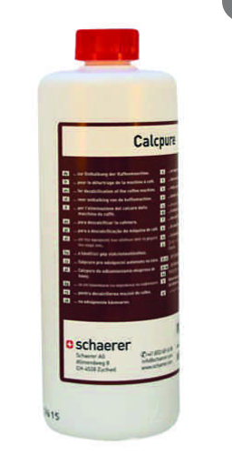
17 |  | 18 |  | 19
SAFECLEAN PLUS ICE MACHINE CLEANER  (Follet) |  | Descaling cartridges |  | LIQUID SCALE REMOVER

Cleaning and descaling SKU information
Pos | SAP | OEM Article | Description | Supplier | Notes
1 | 55121307 | 101100859 | TP SUMA CAFÉ AUTOTAB 60PC C1.7 X2 | Diversey | Cleaning tabs for Espresso equipment Also available as 4016974.
2 | 55115084 | 065221 | CLEANING TABLETS 100 PCS | Schaerer | Tablet for daily cleaning of traditional and automatic Espresso equipment. Suitable for Schaerer, WMF and Franke. (Also available as 4061930)
3 | 55121308 | 101102051 | TP SUMA CAFÉ MLK CL TABL KIT C3.7X1 | Diversey | Also available as 4056510. Cleaning tabs for Milk systems. Milk fats can be removed with alkaline cleaners (big pot) and milk particles with acidic cleaners (small pot). Applicabkle to L’OR SUPRÊME.
4 | 55121745 | 075351 | MILKPURE POWDER 1 BOX | Schaerer | The Milkpure powders contains both alkaline and acidic sachets, optimising milk system cleaning. The alkaline and acidic cleaners can be differentiated by colour.
5 | 55026997 | 062867 | CL.TABLET 1X10-PACK BLIST.1.3G | Schaerer | Also registered as 6286700  TP SCHAERER KAM CLEANER TABL+SP 10PC X.
6 | 55001271 | 071530 | MILKPURE 1000 ML | Schaerer | Cleaning liquid for Milk system Schaerer Coffee Club
7 | 55116055 | 100912198 | TP SUMA CAFÉ TAB 120PC C2.2 X2 | Diversey | Phosphate free cleaning tab for Vending and filter equipment. Also available as 4016975.
8 | 55060967 | 12-M61-UX120-12 | TP RINZA CLEANING TABLETS  120PC X1 | Urnex | Cleaning tabs for Excellence/NG120/  Spro Giro. Also available as 4025909.
9 | 55115573 | 7.193.301.102 | FDSOT RINZA CLEANING TABLETS 100PC X1 | Bravilor | Cleaning tabs for Promesso. Also available as 4055137.
10 | 55117860 | 100889705 | SUMA DESCALE TABS C5.2 2X120PCS | Diversey | Phosphate free cleaning tab for Vending and filter equipment. Also available as 4016975. Applicable to L’OR Supreme.
11 | 55121462 | 7.191.101.212 | CLEANER (4X15 SACHETS OF 15 GR) | Bravilor
12 | 55116892 | 7.190.102.201 | RENEGITE 1 KARTON 10 x 1 KG | Bravilor
13 | 55116395 | 7.190.101.212 | RENEGITE DECALC 15X50G X4 | Bravilor | Is also available as 39700.
14 | 21002663 | 55119528 | Acc NW Descaler 1U ROW 250ml | Evoca | Descale liquid for Saeco / Evoca. Also available as 4057716.
15 | 4057068 | 55126451 | Milk cleaning powder - 6 pb | Evoca | Sachets for milk cleaning Seaco.
16 | 4057067 | 55126450 | Coffee oil remover tablets | Evoca | Cleaning tabs for Saeco.  Also available as 4057067..
17 | 001149962 | 55125979 | SAFECLEAN PLUS ICE MACHINE CLEANER (FOLLET) | Follet | Cleaner liquid for Follett E7 ICE machine. Also available as 4057068.
18 | 079293 | 55118117 | Descaling cartridges |  | Descaling cartridges for Schaerer SOUL and SKYE.  Also available as 4061101.
19 | 062869 | 55097081 | LIQUID SCALE REMOVER |  | Liquid scale remover Schaerer Coffee Club.  Also available as 4061931.

